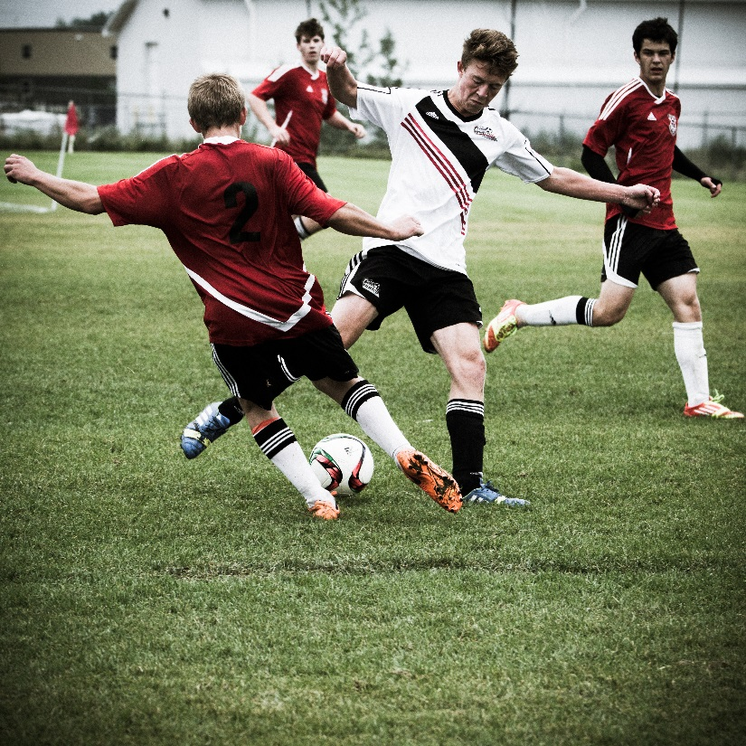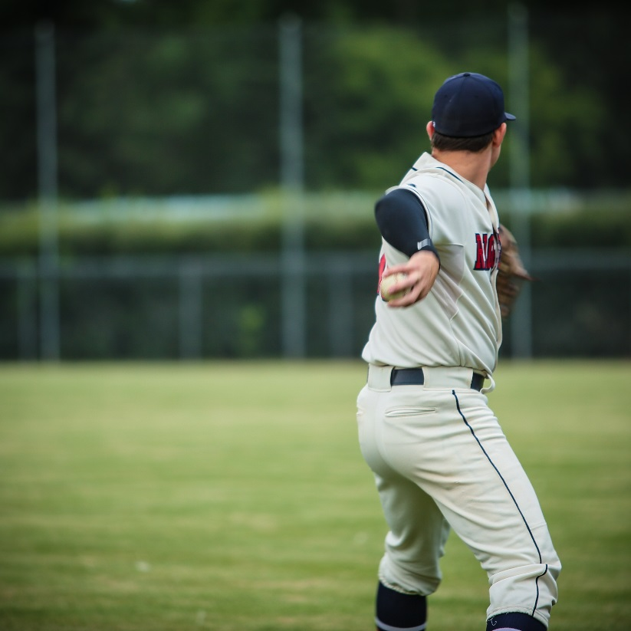
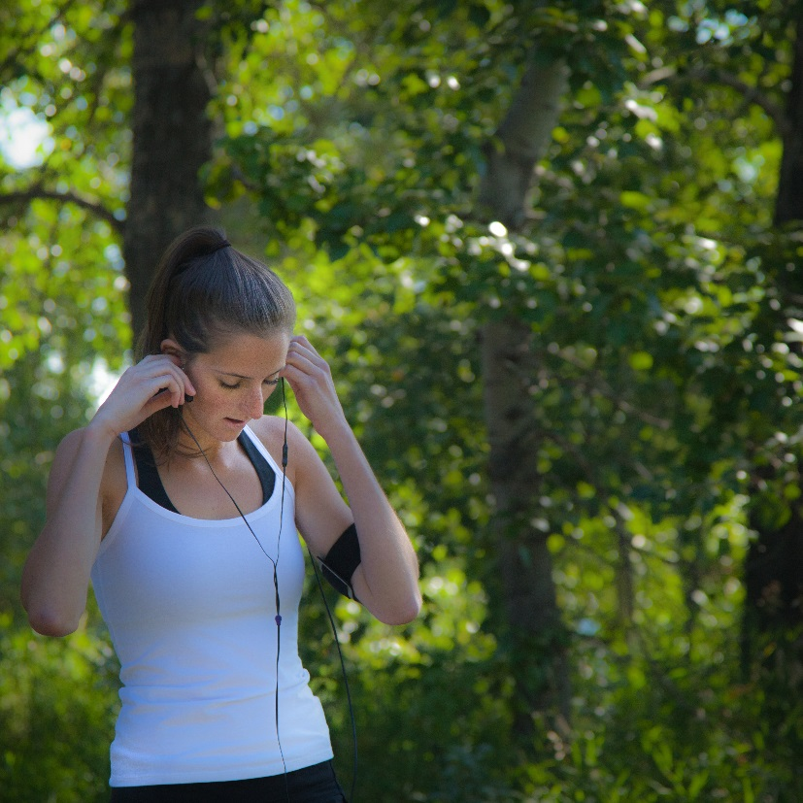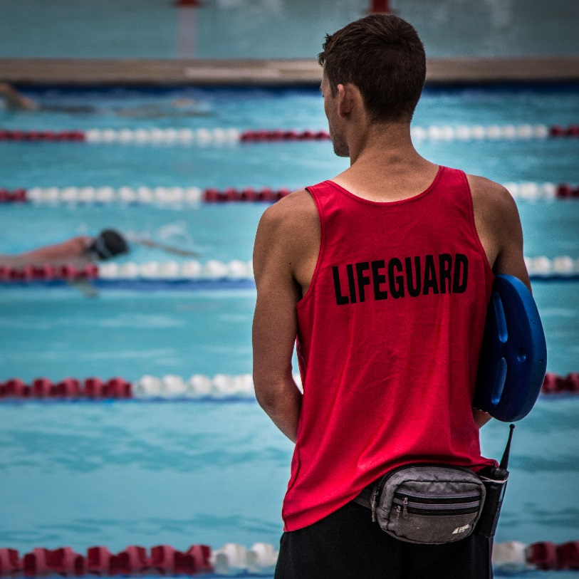
2018 Sport & Special Event
Incentive Program

Suite 350, 4819C – 48th Street, Red Deer, Alberta T4N 3T2 Phone: 403-304-4050 www.hotelreddeer.ca

Hotels Red Deer is pleased to present you with information on our 2018 Sports and Special Events Incentive Program.
This program has been designed to assist and offset costs to organizations, clubs, sport groups and individuals hosting events in Red Deer. It is intended that this fund will provide stimulus and seed money to assist non-profit organizations to host, create, market and administer new sports and special event based events in Red Deer.
Organizers must agree to use Hotels Red Deer partners exclusively for all accommodation requirements.
All requests for funding will be reviewed on an individual basis and supported accordingly. Not all requests received will be approved. Emphasis may be given to events that are:
- Provincial, Western Canadian, National or International Status
- Spring or Summer events held April – August

AUTHORIZED USE OF TOURISM DEVELOPMENT FUNDS:
Monies paid as Sports and Special Event Incentive Program funds pursuant to this policy shall be used for the following:
(1) Promotional, Advertising, and Marketing Expenses. Sports Incentive Program funds must be used to increase participation, attendance, and awareness of a sports or special event, with the direct result of generating increased hotel room nights in Red Deer and Red Deer County during the sports or special event. All promotions, advertising, and marketing paid for with these funds must specifically target a market outside a 50km radius from Red Deer, with all print copy and media consent approved in advance by Hotels Red Deer Staff. Event must showcase partnered only hotels and Hotels Red Deer logo on all marketing pieces, i.e. website, programs, advertising in all forms.
(2) Operational Expenses. We permit these funds to be used to offset, subsidized or fully cover facility related costs that are required in order to allow the event to occur. The facility must be located within Red Deer or Red Deer County. Additionally, we will permit the funds to be used for transportation to support moving participants, related support staff and/or members directly related to the event.
*Please be advised that Hotels Red Deer policy requires the submission of original invoices and copies of canceled checks with all requests for both operational expense and promotional expense reimbursement. Reimbursement will only be made if original invoices and copies of canceled checks are provided. Facility fees are to be paid directly to the facilities, not to the event organizer, after the event and once all room nights have been accounted for and final paperwork has been submitted.
UNAUTHORIZED USES OF FUNDS:
The following are examples of unauthorized use of funds:
(1) prize money, scholarships, awards, plaques, or certificates;
(2) travel expenses;
(3) private entertainment, food, or beverages;
(4) annual operating expenditures not directly related to an authorized event;
(5) legal, medical, engineering, accounting, auditing, planning, feasibility studies, or other consulting services;
(6) salaries;
(7) real property or capital improvements to privately owned facilities;
(8) tangible personal property, including, but not limited to office furnishings or equipment, permanent collections, or individual pieces of art;
(9) interest or reduction of deficits and loans;
(10) expenses incurred or obligated prior to or after the granted event period;
(11) advertising and promotional materials distributed at the event site or after the event.
SPORTS AND SPECIAL EVENT INCENTIVE PROGRAM FUNDING PROCESS INFORMATION FOR APPLICANTS:
1) Events that generate a minimum of 100+ room nights can apply to receive Sports and Special Event Incentive Program funding. Hotels Red Deer staff will review each Sports and Special Event Incentive Program application and make a funding recommendation to the organizations board executive for each application. Hotels Red Deer reserves the right to reduce the amount of funding, or not provide any funding at all, based upon a wide variety of circumstances, including available budget. Once the Sports and Special Event Incentive Program application and funding recommendation is approved by Hotels Red Deer, the applicant will be notified and our office will draft a Sports and Special Event Incentive Program Agreement, which will be sent to the applicant for execution. All Sports and Special Event Incentive Program applications must be submitted a minimum of 90 days prior to the start of the event. Maximum incentive request per event shall not exceed $25,000. Under special limited circumstances, incentives exceeding $25,000 may be considered and approved by Hotels Red Deer. All Sports and Special Event Incentive Program funding exceeding $25,000 must be submitted for review and approval for award a minimum of 120 days prior to the event start.
2) The maximum incentive amount is determined based on a maximum hotel room night multiplier of $12.00 per hotel room night. An applicant must provide the hotel room night guarantee in its Sports and Special Event Incentive Program application, which is then multiplied by the maximum of $12.00 to determine the maximum funding amount that could be applied for and subsequently awarded. Hotels Red Deer has the ability, at its discretion, to reduce the per-room night multiplier and overall funding recommendation for any event.
For example: An event holder applies for a Sports and Special Event Incentive Program funds and guarantees 200 hotel room nights on its application. 200 hotel room nights x $12.00 per hotel room night (maximum hotel room night multiplier approved and recommended by Hotels Red Deer) = $2,400. The maximum incentive amount an event organizer can apply for in the scenario is $2,400.
3) If an event holder is applying for Sports and Special Event Incentive Program funding, with funding to pay the full facility rental for the event, the maximum incentive amount the event holder can apply for shall not exceed the total amount charged for facility rental, although, additional marketing incentive dollars may still be requested in addition to the facility rental costs.
(a) For example: An event applicant is hosting a softball tournament and applying for Sports and Special Event Incentive Program funding to cover the cost of the field rentals at the Great Chief Park for a 2day weekend tournament. Facility rental costs of the complex for the 2day rental is $2,500. The application for Sports and Special Event Incentive Program funding is requesting $2,500, with a minimum hotel room night guarantee of 167 (167 hotel room nights x $12.00 per hotel room night = $2,004), however, the maximum amount that will be granted under the Sports and Special Event Incentive Program for facility rental shall be $2,500.

(b) After the event, the event holder must accurately track and report the total actual confirmed hotel room nights generated from the event to the Hotels Red Deer in the form of hotel teams surveys and confirmed pick up forms from Destination hotels. If hotel room nights meet the guaranteed 167 rooms, then the full amount of the Sports and Special Event Incentive Program funds in this situation will be paid by Hotels Red Deer directly to Great Chief Park.
The Sports and Special Event Incentive Program funding amount paid will never exceed the amount originally approved, even if the actual number of hotel room nights generated exceeds the hotel room night guarantee.
(c) If the actual hotel room count falls below the guarantee, we will use the following formula to determine the maximum incentive Hotels Red Deer would be willing to pay towards the field rental:
(i) For Example:
The event holder’s hotel room night guarantee was 167 rooms, but only 150 hotel room nights were actually documented and reported. To determine the final amount of Sports and Special Event Incentive Program funds to be expended, we will take the actual confirmed and documented hotel room nights multiplied by the agreed upon per-room night multiplier (150 rooms x $12 per hotel room night multiplier = $1,800 maximum Sports and Special Event Incentive Program funding we would pay for this particular event).
(ii) The remaining balance of $250 then must be paid by the event holder directly to the facility used for the event within 30 days of the conclusion of such event. Failure to pay all outstanding balances in a timely fashion may result in loss of future event dates. Failure to properly and accurately report hotel room nights will result in complete loss or significant reduction of Sports and Special Event Incentive Program funding amounts.

4) After an event takes place, the event organizer is required to track and document actual booked hotel room nights and submit all Hotel Room Night Pick Up Forms to the Hotels Red Deer. These forms are to be filled out by the Hotel Sales Manager to document the total number of room nights the hotel received from the event and will be e-mailed, faxed, or otherwise delivered in a timely manner to Hotels Red Deer. For cross referencing purposes, at the discretion of the event organizer, a Hotel Team/Participant Survey may also be filled out and returned by each traveling participating team. The team hotel surveys are not mandatory and are not considered official verification of rooms booked. The event organizer may use the team hotel surveys to confirm, dispute, and/ or verify booked hotel rooms with the hotels but must have the room night pick up form filled out by the hotels as the room night pick up form will serve as the official verification that the County will need to count the total number of rooms booked for the event. These forms will be provided to the event organizer from Hotels Red Deer prior to the event, and will be due back with all other final paperwork no later than 15 days after the event concludes.
5) Hotels Red Deer reserves the right to conduct independent hotel room count audits to verify and confirm rooms reported. The final Sports and Special Event Program funding paid out will never exceed what has been granted and approved.
PLEASE NOTE: All final incentive paperwork, as outlined with the Sports and Special Event Incentive Program Agreement between the event holder and Hotels Red Deer must be submitted within 15 days of the conclusion of the event. The event holder’s request for reimbursement will be considered incomplete unless and until all of the following forms are submitted. Failure to submit reports on time could result in partial or total loss of incentive funding. After an event, the following forms are required to be submitted by the event holder to Hotels Red Deer

General Terms:
- Events must take place over more than 1 day and have an accommodation requirement;
- Accommodation must be booked directly with the hotels; no events using a third-party agency will be eligible;
- Events must use partner destination hotels only (list will be provided);
- For two championships held for the same sport on the same date(s) (i.e. boys and girl’s tournaments), that event is eligible for only one funding incentive;
- The event must be a special one-time event, an inaugural event or an existing event demonstrating expansion or growth; Funding may be provided to an event for a maximum of 3 consecutive years.
- Group must showcase partnered hotels and our logo on all marketing pieces, i.e. website, programs, advertising, etc.
- Incentive funding may be split into two (2) payments (1 pre event/remainder post event) when it is related to promotional marketing only, but is at the discretion of Hotels Red Deer. If this is a need, please outline in the application.

Hotels Red Deer is available to offer planning and promotional assistant to tournament organizers in a number of ways.
- Bid Development & Sourcing
- RFP Distribution, Accommodation Availabilities/Rate Offers
- Coordinate personalized site inspections/venue selections
- Attendance Building Materials (e.g. imagery, video, literature)
- Facilitate connections with local suppliers
- Point of contact to help facilitate and streamline information
- Pre/Post Event Support

Please forward all requests or questions to:
Karen Kitchen
Business Development Manager
Hotels Red Deer
Email: karen@hotelsreddeer.ca
Phone: 403-304-4050

Sport and Special Event Funding Application
Date: Click or tap to enter a date.
General Information
Organization Name: | Click or tap here to enter text.
Contact Name: | Click or tap here to enter text.
Position: | Click or tap here to enter text.
Phone: | Click or tap here to enter text.
Email: | Click or tap here to enter text.
Mailing Address: | Click or tap here to enter text.

Event Information:
Name of Event: | Click or tap here to enter text.
Date(s) of Event: | Click or tap here to enter text.
Location/Venue of Event: | Click or tap here to enter text.
Event Venue Been Secured: | Choose an item.
Event Type: | Choose an item.
Where has the event been in the last 2 years? | Click or tap here to enter text.
Will a City/Venue/Hotel site inspection be required? | Choose an item.
If successful in receiving support on your application, describe the intended use of the funds (should additional space be required feel free to add supplemental information):
[Insert Text}
Have you ever received sport event funds from us before? Is so, for what event:
[Insert Text}

Funding Requested:
Total Amount Organization is Requesting for this event: | $Click or tap here to enter text.
Requesting 50% of awarded funds pre-event: | Choose an item.

Event Participation Details:
Can you provide written confirmation that Event has been secured for Red Deer: Choose an item.
What is the total number of local participants? (coaches, officials, players): Choose an item.
What is the expected number of out of town participants travelling from over 50km away? (coaches, officials, players): Choose an item.
Describe general media coverage expected for this event:
☐ Radio ☐Newspaper ☐TV ☐Website/Social Media ☐Online Ads

If successful in receiving support on your application, how will you recognize Hotels Red Deer in promotional materials/efforts:
{Insert Text}

What other sources of funding/revenue are you pursuing:
{Insert Text}

Describe the potential the sport or event might realize in subsequent years of operation, if applicable:
{Insert Text}
Event Accommodation Outline
Total number of Rooms Required: | Click or tap here to enter text.
What percentage is booked by the organization: | Click or tap here to enter text.
Is a host hotel required? | Choose an item.
Have any accommodation contracts been confirmed prior to application submission: | Choose an item.
Include any additional event details:
{Insert Text}

Our Destination Partners:
Note that these are the only hotels permitted to be supported in order for funding to be issued.
Best Western Plus Red Deer Inn & Suites Days Inn
6839 – 66 Street 1000, 5001 – 19th Street
403-343-6666 403-340-3297

Motel 6 Red Deer Radisson Red Deer
900, 5001 – 19th Street 6500 – 67th Street
403-340-1749 403-342-6567

Sandman Hotel Red Deer Sheraton Red Deer Hotel
2818 Gaetz Avenue 3310 – 50th Avenue
403-343-7400 403-346-2091

Towneplace Suites Marriott
6822 – 66 Street
403-341-3598

Westerner Park
4847A – 19th Street
403-343-7800
Website

